History Intent
Our aim is to encourage pupils to develop an appreciation and understanding of the past, through evaluating a range of primary and secondary sources. We want our historians to be able to explain clearly how these sources give us an insight into how people around the world used to live and how these interpretations may differ. Pupils will be taught to make links between these areas of learning, with the aim of developing engaged, motivated and curious learners that can reflect on the past and make meaningful links to the present day.
Our History curriculum has been designed to cover all of the skills, knowledge and understanding as set out in the National Curriculum. The National Curriculum states that ‘a high-quality history education will help pupils gain a coherent knowledge and understanding of Britain’s past and that of the wider world. It should inspire pupils’ curiosity to know more about the past.’
To ensure that pupils develop a secure knowledge that they can build on, our History curriculum is organised into a progression model that outlines the skills, knowledge and vocabulary to be taught in a sequentially coherent way. Chronological Understanding; Historical Understanding; Historical Enquiry; Interpretations of History; Organisation and Communication are all mapped out to ensure that pupils build on secure prior knowledge.
When covering each of these strands, the content will be carefully organised by each year group through a long term plan. Content knowledge, vocabulary and skills will then be planned for at a greater level of detail in the medium term plan. History is delivered through subject specific teaching organised into blocks under a theme. Meaningful links with other subjects are made to strengthen connections and understanding for pupils.
The units have been developed to help children appreciate their own identity and the challenges in their time. It will help them understand the process of change over time and significant developments and events locally, nationally and globally.
Developing as a Historian requires all aspects of the discipline to be developed together. The curriculum must include “Historical knowledge” and “historical skills and concepts” which become blended. History knowledge is cumulative and deepens when concepts are compared and evaluated. Hence why it is important that some key Historical concepts will be visited through every year group. All activities will deepen the children’s understanding of one or more of the following concepts:
- Continuity and change in and between periods
- Cause and consequence
- Similarity / Difference within a period/situation (diversity)
- Significance of events / people
Progression of key concepts within our curriculum
 | EYFS | KS1 | KS2
Continuity and change in and between periods | - Look closely at similarities, differences, patterns and change  - Develop understanding of growth, decay and changes over time | - Identify similarities / differences between ways of life at different times | - Describe / make links between main events, situations and changes within and across different periods/societies
Cause and consequence | - Question why things happen and give explanations | - Recognise why people did things, why events happened and what happened as a result | - Identify and give reasons for, results of, historical events, situations, changes
Similarity / Difference within a period/situation (diversity) | - Know about similarities and differences between themselves and others, and among families, communities and traditions | - Make simple observations about different types of people, events, beliefs within a society | - Describe social, cultural, religious and ethnic diversity in Britain & the wider world
Significance of events / people | - Recognise and describe special times or events for family or friends | - Talk about who was important e.g. in a simple historical account | - Identify historically significant people and events in situations

History Implementation
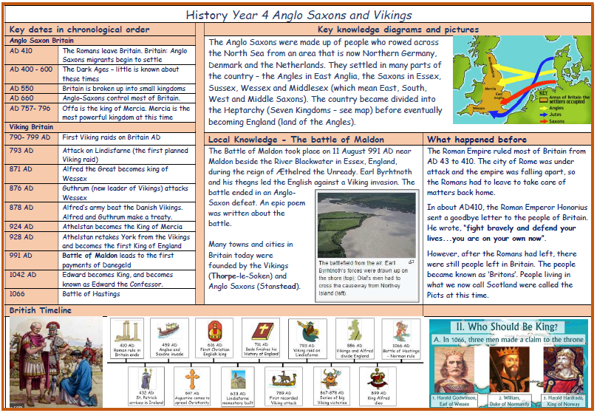
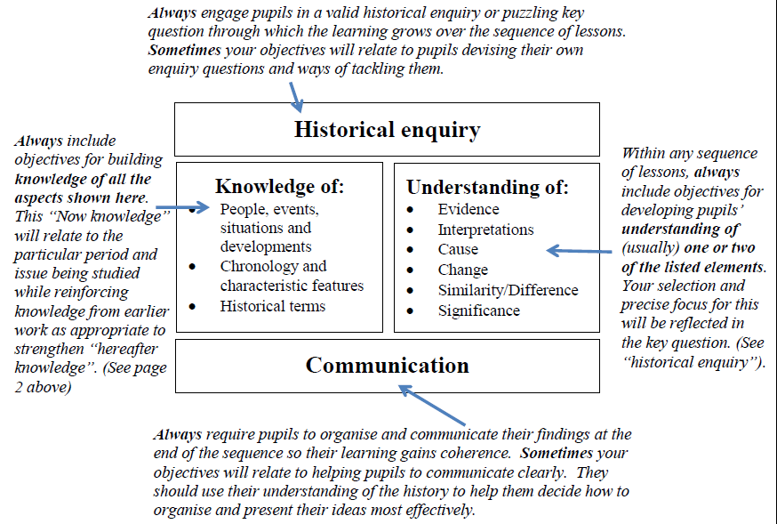
Knowledge Organisers and Knowledge Walls - Children have access to key knowledge, relevant language and meanings to use in History and to use across the curriculum.
Key Vocabulary - The promotion of a language rich History curriculum is essential to the successful acquisition of knowledge and understanding in History
Context - New history learning is put into the context of the big picture of 1) history learning throughout school, and 2) a daily review of immediate previous learning in the subject
Provision in EYFS - Children are given a secure grounding in the Prime Areas of learning, ensuring they have a good foundation on which to build through the specific areas, including understanding the World. Areas of provision are enhanced to ensure vocabulary understanding and extension, and develop understanding of the past, present and the difference between the two.
Chronology and class timelines – Each era of study refers back to school/class timeline. Teachers prompt the children to put new learning in the context of previous learning.
Use of artefacts - Where possible we use artefacts for children to explore and investigate. We believe that handling or viewing real objects enhances the children’s historical knowledge, understanding and skills.
Evaluation of sources / bias - We aim for children to recognise that bias exists in some form in all historical sources, and this needs to be accounted for in their interpretation of evidence.
Outdoor learning - We recognise that children learn in a variety of ways, so where appropriate, children will learn history outside the classroom.
Basic skills - English, Maths and computing skills are taught during discrete lessons but are revisited in history so children can apply and embed the skills they have learnt in a purposeful context.
Independent learning - In History, children are encouraged to enquire about their topic of interest to both satisfy curiosity and develop their independence. Children will be asked to research historical aspects of their learning independently. This allows the children to have ownership over their curriculum and lead their own learning in history
Artefacts, text books, digital technology and photographs. - Children will use a range of secondary resources to develop their knowledge and understanding that is integral to their learning.
Educational Visits & visitors to enhance their cultural capital – Visits, visitors and involvement in the community will be planned to provide first hand experiences for the children to support and develop their learning and cultural capital. These are explicitly linked to statutory historical knowledge.
Learning, working and talking like a Historian - Children are introduced to the key vocabulary that a Historian would use. They will define the key vocabulary that a Historian would use. There is a high expectations of pupils ‘talking’ like a Historian.
British Values and PSHE - Children will learn and revisit the importance of our world today and how it should be treated through a range of cultural capital activities and experiences.
Our history skills progress through each primary year under the following headings
Investigate and interpret the past
- Questions
- Sources
Build an overview of world history
- Describe
- Compare
Communicate history
- Vocabulary
- Presentation
Our curriculum Programme
Knowledge Themes by year group
Year 1 | Inside & outside living memory | Year 3 |  | Inventions that changed the world (stone age to iron age) | Year 5 |  | Ancient Civilizations
Year 2 | Local history or significant individual study | Year 4 |  | Anglo Saxon and Vikings (local history link) | Year 6 |  | Empires (local history link)
In History, like all other subjects, we recognise the importance of the methods and practice of teaching (the pedagogy) we choose to use in enabling pupils to know more, understand more and remember more. In History, the following approaches will be used, and be evident in lesson observation, pupil voice and, when appropriate, children’s curriculum books, in order to ensure that the Geographical learning opportunities are as effective as possible and that pupils progress throughout the year and across year groups during their historical experiences in school:
Teaching Sequence in History. Every year group’s unit of work should include: |  |  | Possible pedagogical quality first teaching approaches used in History to support children with SEN:
Historical Enquiry  Conduct Historical enquiry using a variety of sources and / or artefacts and asking key questions  What was daily life like then?  How does it compare with my life now?  What did that mean for the people of the time?  How does that compare with other periods of history? |  |  | Prepare the pupil before the session/lesson by outlining what it will be about. Use TA for pre-tutoring – preparing pupil for a task so that they come to it already knowing the key vocabulary and concepts |  |  | Use a visual way of showing the pupil what they/the class will be doing, such as a sequenced series of pictures (a visual timetable), clock-face divided into sections, or written list
Big picture:  Placing of the History being studied in the chronological context of previous learning, using the class/school timeline  Evaluate their learning and compare with other historical periods studied as appropriate |  |  | Set tasks with clear goals and write worksheets in step-by-step form |  |  | Use a kitchen or sand timer to help pupil complete a task in a specified period of time
Vocabulary  Specify key subject specific and content specific  vocabulary to be used and its meaning.  All pupils will access language from their knowledge organisers and knowledge walls within the classroom  Being introduced to the key subject specific and content specific vocabulary that a historian would use; defining the key subject specific and content specific vocabulary that a historian would use; |  |  | Provide support in the form of writing frames, word mats, relevant classroom displays, and prompts such as a card with ideas for ‘Five things to do if you are stuck with your work’ |  |  | Support writing with writing frames, templates (e.g. writing up a science experiment), mind maps, gapped handouts
Communicate  Communicate their historical knowledge and understanding appropriately Interpret their findings  Have high expectations of pupils ‘talking’ like a historian; and presenting like a historian |  |  | Use visual prompts in the form of pictorial task cards |  |  | Link new learning to what pupil already knows – e.g. start lesson with class mind map of what they already know about a subject
Apply their knowledge to their way of life today  These connections can be made across other subject areas (geography/PSHE/science)  How does this apply to my life today?  What could/should the world be like in the future? |  |  | Design worksheets so that the layout is uncluttered. Use buff or cream paper, large print (12–14 point) and a clear font such as Arial. Set information out in panels. Signpost sections with key words, symbols and pictures. Put important information in bold or colour |  |  | When you start a new topic, develop a class chart of the vocabulary that pupils will find useful or need to learn. Teach each word by helping children build a web of associations – what it sounds like, what it means, how it fits in a sentence

History Impact
We will know that our history education has been successful in our school when the children leave curious about the world around them; When they generate questions to help them investigate the past and evaluate their life today, because they have a good understanding of local and national and world history.
- Children will understand History concepts outlined above.
- Children will understand and use the key skills of chronological understanding, Knowledge and understanding of events in the past, Historical interpretation, Historical enquiry and organisation and communication.
- The large majority of children will achieve age related expectations in History.
- As Historians children will learn lessons from history to influence the decisions they make in their lives in the future.
- Children will know about history in their local area.
- Understand the methods of historical enquiry, including how evidence is used rigorously to make historical claims, and discern how and why contrasting arguments and interpretations of the past have been constructed
- Children will know and understand the history of these islands as a coherent, chronological narrative, from the earliest times to the present day: how people’s lives have shaped this nation and how Britain has influenced and been influenced by the wider world
- The pupil voice will represent an understanding of what history is and how they have applied this learning in a given context as part of a highlight task.
- Children will work collaboratively to investigate the past and explain the processes that they have taken
- Children will be able to apply their knowledge in a secondary setting.

